Right click on the hostname after File->Connect:

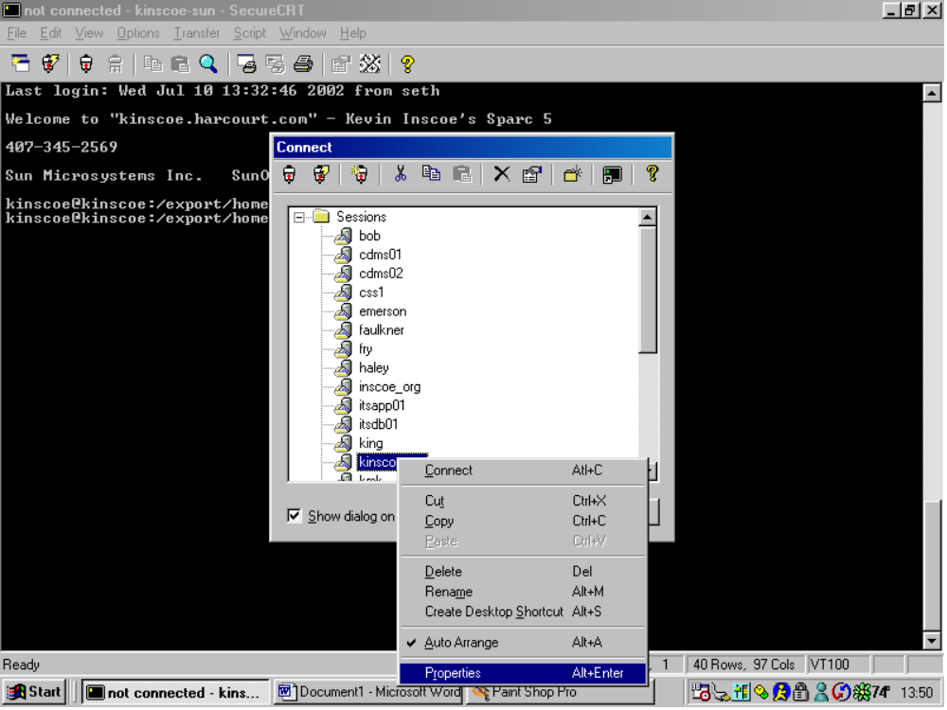

Then select properties.

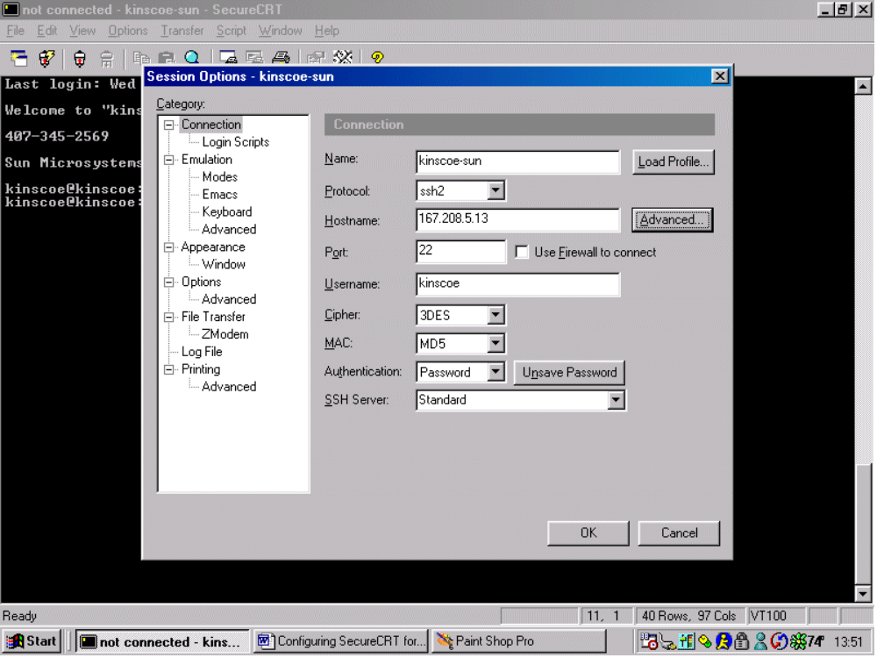

Select Advanced. The check off “Forward X11 Packets”.



